Ryufath Alief Adhyaksa Putera Soepeno

Information Systems

Fundamentals of DBMS

20/2/2022

Given relational schema (See Slide p 20, Module 5):

Sailors (sid, sname, rating, age)

Reservation (sid, bid, date)

Boats (bid, bname, color)

THESE ARE LEVEL 2 SQL

TABLES:

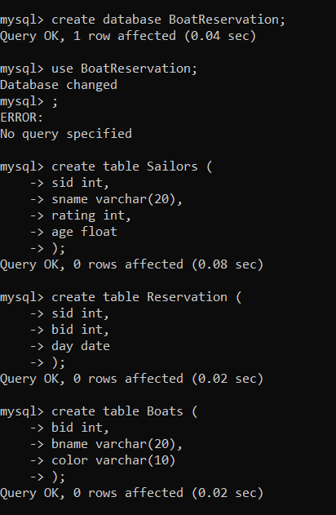

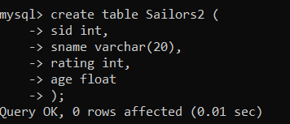

INSERT VALUES (Based on p.5):

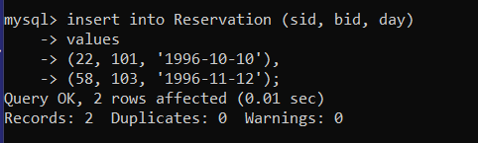

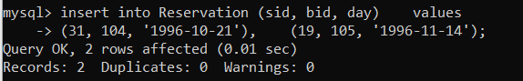

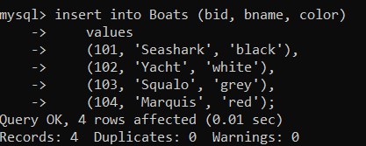

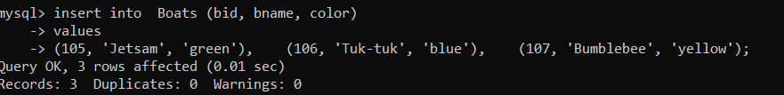

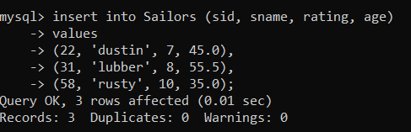

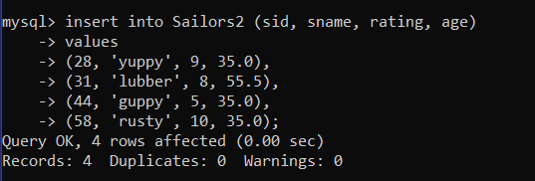

For the following queries:

1)Find names of sailors who’ve reserved boat #103 ‘

1. Relational Algebra

**π bid, sname(σ (bid = 103) Sailors ⋈ Reservations)**

**FIXED:**

2. Convert your answers from relational algebra to sql

**SELECT A.sname, R.bid FROM Sailors A, Reservation R WHERE R.bid = 103 AND A.sid = R.sid;**

3. Create the database in the my-sql and try your queries

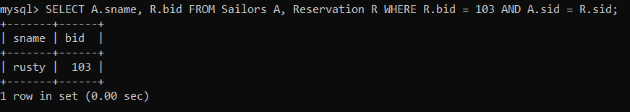

2)Find names of sailors who’ve reserved a red boat

1. Relational Algebra

**π color, sname (σ (color = ‘red’) Sailors ⋈ Reservation ⋈ Boats)**

2. Convert your answers from relational algebra to sql

**SELECT A.color, C.sname FROM Boats A, Reservation B, Sailors C WHERE A.color = 'red' AND A.bid = B.bid AND B.sid = C.sid AND C.sname = C.sname;**

3. Create the database in the my-sql and try your queries

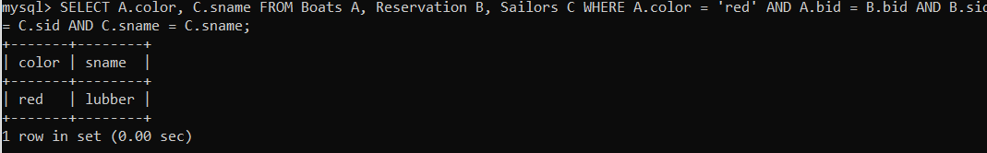

3)Find names of sailors who’ve reserved a red or a green boat

1. Relational Algebra

**π color, sname (σ color='red' ∨ color='green' Boats ⋈ Reservation ⋈ Sailors))**

**FIXED**

2. Convert your answers from relational algebra to sql

**SELECT A.color, A.bid, B.sid, C.sname FROM Boats A, Reservation B, Sailors C WHERE A.color = 'red' AND A.bid = B.bid AND B.sid = C.sid;**

3. Create the database in the my-sql and try your queries

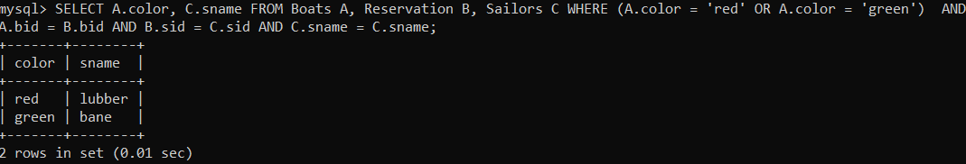

4)Find names of sailors who’ve reserved a red and a green boat

1. Relational Algebra

**π color, sname (σ color='red' ^ color='green' (Boats ⋈ Reservation ⋈ Sailors))**

**FIXED:**

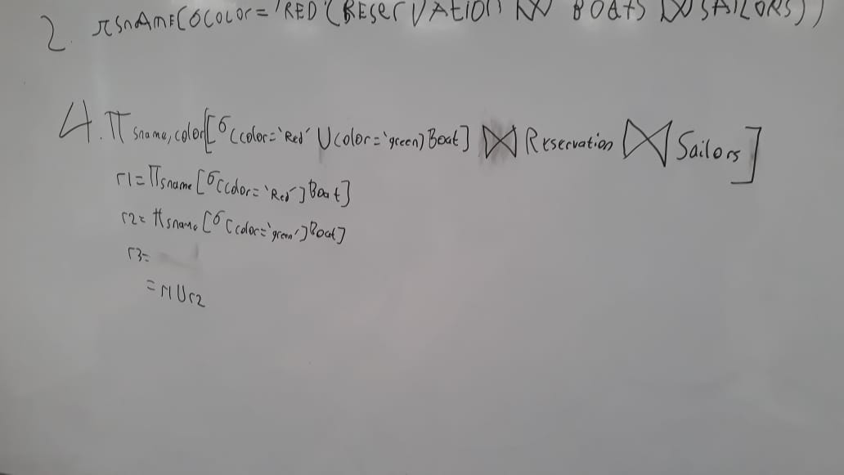

2. Convert your answers from relational algebra to sql

**SELECT A.color, C.sname FROM Boats A, Reservation B, Sailors C WHERE A.color = 'red' AND A.color = 'green' AND A.bid = B.bid AND B.sid = C.sid AND C.sname = C.sname;**

3. Create the database in the my-sql and try your queries



5)Find the names of sailors who’ve reserved all boats

1. Relational Algebra

**π sname, name, bid, day (σ S.sid = R.sid (Boats ⋈ Sailors ⋈ Reservation))**

$π_{ color, sname}(σ_{(S.sid = R.sid ∧ R.bid = B.bid)} Sailors ⋈ Boats ⋈ Reservations)$

**or**

**π sname (σ (S.sid = R.sid) ÷ (B.bid = R.bid) (Boats ⋈ Sailors ⋈ Reservation))**

**FIXED:**

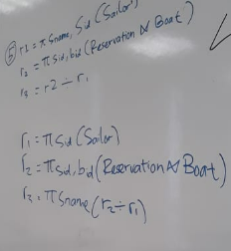

2. Convert your answers from relational algebra to sql

**SELECT S.sname, B.bname, R.bid, R.day FROM Sailors S, Boats B, Reservation R WHERE S.sid = R.sid AND R.bid = B.bid;**

**or**

**SELECT S.sname, B.bname, R.bid, R.day FROM Sailors S, Boats B, Reservation R WHERE S.sid = R.sid / R.bid = B.bid;**

3. Create the database in the my-sql and try your queries

